Assignment 2

Exercise 1

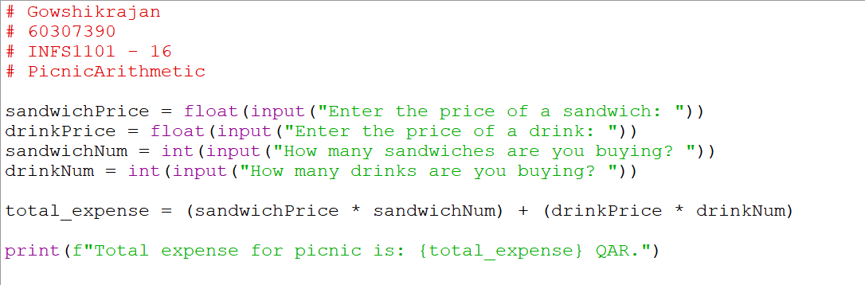

Flowchart 1

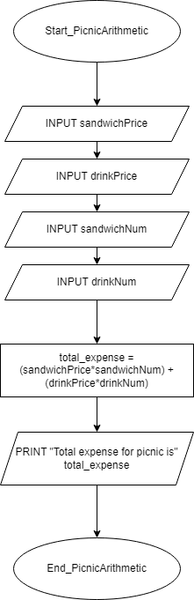

Exercise 2

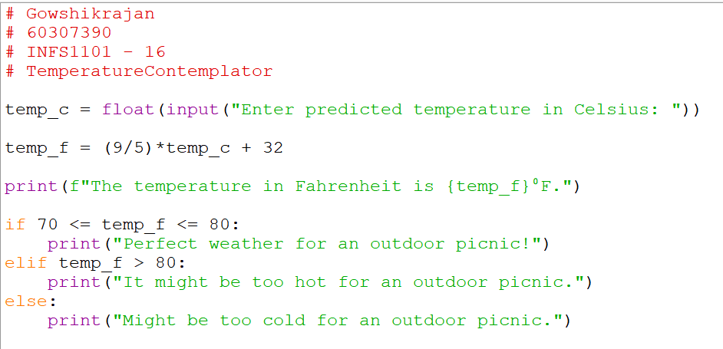

Flowchart 2

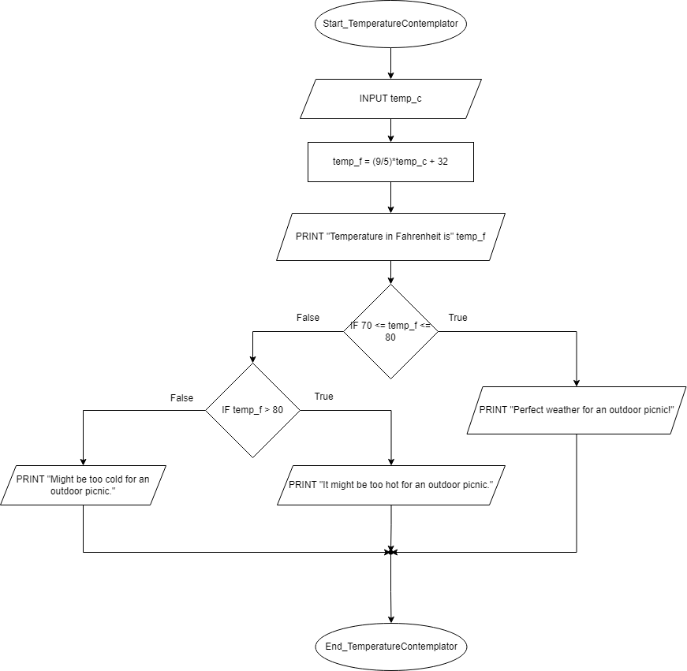

Exercise 3

Flowchart 3

Exercise 4

Flowchart 4

